# Microscale intraspecific variability in seed germination responses to water stress in Mediterranean alpine ecosystems

Abstract

## 1. Introduction

Intraspecific variability plays a key role in a wide range of biological processes, from individual fitness to population dynamics, species interactions, community assembly and ecosystem properties (Westerband et al. 2021). Intraspecific variation has been hypothesized to be a response to heterogeneous environments (Van Kleunen & Fischer 2005) and an indispensable condition for plants to adjust to novel environmental conditions (Jump et al. 2009). The adjustment comes from two non-exclusive mechanisms: (1) local adaptation (i.e. adaptive evolution) and (2) phenotypic plasticity (i.e. acclimatisation) (Nicotra et al. 2010; Reed et al. 2011, …, …). Adaptive evolution is a long-term process of genotypic changes that widen a species’ potential niche, but each locally adapted population becomes limited in the conditions in which it can survive, thus becoming more sensible to local threats if dispersal and gene flow are limited (Atkins & Travis 2010; Valladares et al. 2014), especially under current global change (Peterson et al. 2018). In this situation, phenotypic plasticity may be the key to fast plant responses to new conditions (Matesanz et al. 2010; Nicotra et al. 2010; Reed et al. 2011; Walck et al. 2011), acting as a buffer against environmental changes (Lande 2009; Chevin et al. 2010).

Among other things, environmental changes can pose challenges to successful plant regeneration from seeds, a key life history process that determines the ability of plant populations to migrate or persist (…, …, …). Seed germination is an ecophysiological process driven by moisture and temperature (Bewley et al. 2013) and, thus, it is highly sensitive to changes in these two environmental factors (…). Iresponses to moisture and temperature will be key for theadaption or acclimatization of plant regeneration to ongoing climate change . However, compared to temperature (…, …, Fernández-Pascual et al. 2019), fewer studies have tackled how the germination of wild species responds to changes in water stress (Bernau et al. 2020; Sumner & Venn 2021). Most information about drought effects on germination comes from studies on arid ecosystems (Yi et al. 2019; Gelviz-Gelvez et al. 2020); in those investigations, responses vary notably depending on species own trade-offs (Kos & Poschlod 2008) and even within species (Yi et al. 2019). A promising approach to study seed responses to moisture and water stress is the application of developmental threshold models (…), specifically, the modelling of the seed germination niche using hydro-time models (Bradford 2002; Allen et al. 2009; Bewley et al. 2013). In the hydro-time framework, for germination to happen, water availability in the environment must surpass a specific threshold (i.e. the base water potential, ψb). Each seed in a population has its own value of ψb, and therefore calculating this parameter and its variation allows to test the sources and mechanisms of variation among individuals (i.e. intraspecific variability in seed responses to water stress) (…).

Global warming is a major challenge for worldwide alpine ecosystems. International records show higher temperature increases (REF) and associated changes in summit plant communities (…). The high topographic complexity observed at fine scales in alpine ecosystems (Scherrer & Körner 2011) allows a mosaic of microclimatic conditions (Körner 2021) with sharp gradients within few centimetres (Graham et al. 2012). Thus microclimatic variability has been seen to partially buffer climate warming (Körner & Hiltbrunner 2021) through communities shifting distributions (paper picos 2024 JVA). Nevertheless, there is still a need to assess the effects of unpredictable precipitation and earlier snowmelt, which could result in water stress during summer (IPCC 2014). Alpine plant regeneration studies have mostly focused on the effects of temperature and warming (e.g. Mondoni et al. 2012; Hoyle et al. 2015; Fernández-Pascual et al. 2021), as if moisture was not a limiting factor in temperate alpine regions. However, recent research has shown that germination is specifically triggered by high soil moisture in alpine habitats of the Caucasus (Rosbakh et al. 2022). Water stress should be especially relevant in the Mediterranean high mountains, alpine areas with a two-month drought period in summer (Sumner & Venn 2021) where Mediterranean-like germination syndromes have been described (Giménez-Benavides et al. 2005; Giménez-Benavides et al. 2018). Another limitation of alpine germination studies is that they are mostly focused on population and community levels (e.g. Cavieres & Arroyo 2000; Shimono & Kudo 2005; Wagner & Simons 2009), with few studies at subpopulation level (Gya et al. 2023) and even less considering the mosaic of microclimatic conditions at fine scales (Scherrer & Körner 2011).

This article tackles the understudied topic of intraspecific variability on germination responses to water stress. It does so by focusing on microscale (c. 10 m) variations in germination and water availability in drought-limited Mediterranean alpine grasslands of the Iberian Peninsula. Using as a study system the wild carnation *Dianthus langeanus* Wilk. (Caryophyllaceae), we test the hypothesis that germination responses to water stress will show functional intraspecific variability along local water availability gradients. Our prediction is that seeds from warmer and drier subpopulations will have lower base water potentials for germination (i.e. higher germination tolerance to water stress).

However, to calculate the base water potential using hydrotime models, non-dormant seeds are needed (ref bradford?), but no previous studies (to our knowledge) have measured seed dormancy alleviation in our study species. Based on available information on the germination of Mediterranean species (…), we hypothesize that fresh seeds of *D. langeanus* might show some degree of physiological seed dormancy that requires dry after ripening to be alleviated. Thus, a secondary prediction that needs to be checked is that seed storage in dry after ripening conditions will modify seed dormancy and thus germination responses to water stress.

Seed mass?

## 2. Methods

### 2.1. Study system

*D. langeanus* Wilk. (Caryophyllaceae) is a wild carnation endemic to the mountain systems of the northwestern Iberian Peninsula (shadowed area in Fig 1A, adapted from Rocha et al 2017). *D. langeanus* mainly lives in open dry grasslands on acid soils (Fig 1B), where it can be locally abundant. Flowering onset occurs in early June (Fig 1C), and ripe seeds are dispersed during August. Seed production is high, usually >10 seeds per capsule and up to 250 seeds per individual. Germination occurs mainly during end-summer/early autumn at high rates and with high success when water is available at temperatures between 10 and 22 ºC (move along paper). For this article, we studied wild populations of *D. langeanus* in the northern limit of its distribution, in the Valles de Omaña and Luna Biosphere Reserve, in the southern ranges of the Cantabrian Mountains (Fig 1A, red square). The Cantabrian Mountains run E-W in northern Spain along 480 km in parallel to the Cantabrian Sea …. This mountain system includes summits above 2,500 m a.s.l and the treeline in acids soil climbs up to 1650m a.s.l (ref TFM Jorge). It is considered a transitional biogeographical hub between the Eurosiberian and Mediterranean regions (Jiménez-Alfaro et al. 2021), influenced by the Mediterranean climate on the southern slopes and the temperate climate on the northern slopes.

### 2.2. Field sites

We established a systematic sampling across four summits above 2000 m a.s.l. (Fig 2 upper panel) where *D. langeanus* was highly abundant. ~~all located above acidic bedrock (soil pH 3.8 – 4.8, own data)~~. In each summit, we established a central representative plot (3m radius) where we did a floristic relevé and buried, at 5 cm deep, a Microlog SP3 datalogger, with hourly records of soil temperature and water potential (datalogger MicroLog SP3, EMS Brno, Czech Republic; accuracy in temperature measurements: +/- 0.3 ºC from -40 ºC to 60 ºC; water potential measurements with two Delmhorst gypsum sensors measuring range from -0.1 to -15 bars (permanent wilting point); records every hour). The recording period for the Microlog SP3 went from June 2021 and is currently ongoing. To measure the spatial microenvironmental gradients we then established 20 additional plots (1m2) per each summit: five plots in each cardinal direction with a 10 m separation (cross design, Fig 2 lower panels). Here, we also did floristic relevés and buried, at 5 cm deep, iButton dataloggers (Thermochron, iButton, Newbury, UK; accuracy: +/- 0.5 ºC from -10 ºC to +65 ºC, resolution: 0.5 ºC, records every four hours). The recording period for the iButtons went from 12 July 2021 to 29 May 2022 (321 days). In total, we collected floristic data from 84 plots and environmental data from 78 plots (one MicroLog SP3 was damaged, and 5 iButtons could not be recovered).

*D. langeanus* was present in 47 out of 84 plots (Fig 2 lower panels, coloured diamonds). In the subpopulations where *D. langeanus* was present, local community richness ranged from 3 to 14 species (average of 8 species). *D. langeanus* communities were dominated by the hemicryptophytes *Festuca summilusitana* Franco and Rocha Afonso (Poaceae) and *Luzula caespitosa* J. Gay ex E. Mey. Steud (Juncaceae). The most frequent accompanying species were *Sedum brevifolium* DC, *Neoschischkinia truncatula* subsp. *durieui* Boiss. & Reut. ex Willk. Valdés & H.Scholz and *Armeria duriaei* Boiss.

Soil climate was typically Mediterranean, with a 2-month drought period in summer (Fig 3A, grey bars representing soil water potential). The growing season stretched from April to November with a mean annual soil temperature of 8 ºC. Monthly maximum and minimum soil temperatures reached up to 40 ºC in summer and went down to -4 ºC in winter (Fig 3A, red lines). ADD days with water stress in the growing season and mean of days with snow (high variations according to orientation of slope).

### 2.3. Microclimatic indices

We used the records of our dataloggers to calculate soil microclimatic indices as in Paper picos. For comparison, we homogenized the data between the two data loggers (MicroLog SP3 and iButtons) by keeping the same recording frequency (every four hours) and the time period with records for all loggers (the 321 calendar days from 12 July 2021 to 29 May 2022). We calculated bioclimatic indices based on WorldClim standard bioclimatic variables (Fick & Hijmans 2017), together with other variables relevant for describing alpine micro topographical gradients. We selected 6 temperature-related indices: (1) bio1 = annual mean temperature; (2) bio2 = mean diurnal range, i.e. the mean of the monthly differences between maximum and minimum temperatures; (3) bio7 = temperature annual range; i.e. the difference between the maximum temperature of the warmest month and the minimum temperature of the coldest month; (4) snow = the number of days of snow cover, when the soil temperature is around 0 ºC, calculated for the period in which the maximum temperature was < 0.5 ºC and the minimum temperature was > -0.5 ºC; (5) FDD = freezing degree days, i.e. the sum of daily mean temperatures for days in which the mean temperature was below 0 ºC (Choler 2018); and (6) GDD = growing degree days, i.e. the sum of daily mean temperatures for days in which the soil mean temperature at five cm deep was above 5 ºC (Körner 2021). For easier interpretation of FDD, we transformed the values from negative to positive, so higher values represent more freezing.

To identify the main gradients of microclimatic variability, we conducted a principal component analysis (PCA) including all bioclimatic indices (Fig 3C). Axis 1 of the PCA explained 64% of the variance and ordered the 78 plots along a gradient of thermicity, towards which the greatest contribution was made by GDD (23.4) and bio1 (23.5). GDD was highly correlated with bio1, bio2 and bio7 (> 70%, details in Supplementary xxx). Therefore, we decided to use GDD as the single best descriptor of microclimatic variability for further analyses.

Since we only had water stress measurements for the central plots, we had to confirm the expectation that warmer microsites were also drier. To do this, we took our GDD measures and plotted them against the cumulative water potentials values at the subpopulation level, when available. We used Microlog SP3 data collected for our four summits in 2022 and 2023 to test if, as expected, there was a positive relationship between GDD and water potential (ΣΨ, R2=0.69, Fig 3B) i.e. warmer years are also drier years.

### 2.4. Seed collection

We sampled seeds of *D. langeanus* from each plot where the species was present (Fig 2 lower panels). We collected mature fruits (capsules) at the time of natural dispersal (August 7-8th, 2023). In each subpopulation, within a 2m radius from the datalogger, we sampled at least 20 randomly selected mother plants following standard protocols for sampling seeds of wild populations (ENSCONET, 2009). In total, we sampled 47 plots with *D. langeanus* but only were able to collect enough seeds for experiments (> 600 seeds) from 18 of them, hereafter called “subpopulations”. Immediately after collection, we manually cleaned the seeds and kept them at room conditions (22 ºC and 35 % RH) until the start of the germination experiments. For each subpopulation used in subsequent experiments, we measured dry seed mass by weighing 10 individual seeds from each subpopulation after the seeds had spent 3 months drying with silica gel (Mettler Toledo, New classic SG – Model ML1052E/01, precision 0.1 mg).

### 2.5. Germination experiments

We wanted to measure germination responses to water stress in functionally significant ecological conditions, i.e. using fresh seeds at the time of dispersal. However, although our previous experiments indicated high germination in relatively fresh *D. langeanus* seeds, we also expected that the seeds could show some light level of physiological dormancy and that they could require dry after-ripening to release this dormancy, as mentioned above. Since we wanted to calculate hydro-time models, and these models require working with non-dormant seed lots, we decided to repeat the experiments with two seed storage treatments: fresh seeds (10 days after collection, hereafter called “fresh”) and after ripened seeds (45 days after collection, hereafter called “after ripened”). For each storage treatment, we used 12 subpopulations, as seed numbers allowed: 6 subpopulations were repeated for both treatments, 6 subpopulations were used only for the fresh treatment, and 6 subpopulations were used only for the after ripened treatment (Table 1).

To test the seed germination responses to water stress, we performed laboratory experiments using polyethylene glycol (PEG, an inert water-binding polymer) solutions to simulate different water potential scenarios. PEG solutions maintain relatively steady and precise osmotic potentials to study germination water thresholds (ref). Since we could not find previous information about the species water potential requirements for germination, we performed a previous pilot study that showed zero germination at -1.4 and -1.6 MPa. Thus, we excluded those levels and selected seven water potential treatments for the final experiment: 0, −0.2, −0.4, −0.6, −0.8, −1 and −1.2 MPa. For each treatment combination (7 water potential treatments x 2 storage treatments x 12 subpopulations) we sowed four Petri dishes with 25 seeds each (except in the -1 and -1.2 MPa water potential treatments, where we expected low germination, and we sowed only 2 dishes with 25 seeds each). We used 90 mm Ø Petri dishes with two layers of filter paper (Filtros Anoia S.A. paper for germination assays, Ref.518G085). To each dish, we added 5 ml of either (a) distilled water or (b) a PEG 6000 solution prepared according to Michel & Kaufmann (1973) and (Villela et al. 1991) to reach desired osmotic potentials at 20 ºC (the experimental temperature). We sealed Petri dishes with parafilm to avoid evaporation of the solutions and to maintain constant water potentials throughout the experiment.

Seeds were incubated in conditions simulating late summer days in the field, when germination has been described to happen (paper move-along): constant 20°C with a daily photoperiod of 12-12h light/dark. It must be noted that we used constant 20ºC rather than a more realistic diurnal alternating regime in order to maintain the stability of water stress conditions for the PEG solutions. Conditions were programmed in an incubator (Aralab climatic chamber Fitoclima S600 PL, equipped with four led modules 11W 350mA). We monitored germination, defined as radicle emergence > 1.5mm, for 28 days: daily until the cumulative germination curve flattened (day 21) and then every two or three days until the end of the experiment. We removed germinated seeds during the scoring and, once the experiments were finished, we cut non-germinated seeds under a binocular loupe and classified them as viable, dead or empty. Seeds with firm and white embryos were considered viable, i.e. potentially germinable (Baskin and Baskin 2014). Subsequent analyses only consider germinated and germinable seeds. A total of xxxx viable (germinated + germinable) *D. langeanus* seeds were used in this study.

### 2.6. Data analysis

### All analyses were done in R (R Core Team 2022) using the packages glmmTMB (Brooks et al. 2017) for fitting Generalized Linear Mixed Models (GLMMs) and seedr (Fernández-Pascual & González-Rodríguez 2020) for fitting hydro time models. Model fit and residuals were visually checked using the DHARMa package (Hartig 2020). Data visualization was created with packages ggplot2 (Wickham 2016) and patchwork (Pedersen 2023) with the wesanderson palette (Ram & Wickham 2023).

To test our secondary prediction, if final germination varied as a function storage time and water potential, we fitted GLMMs with binomial distribution. Final germination proportion was the response variable. Explanatory fixed factors were the storage and water potential treatments. Random factors included subpopulation nested within summit. Model formula: Final germination (germinated, viable - germinated) ~ storage * water potential + (1|summit/subpopulation), family = binomial.

To test our primary prediction, if base water potential varied as a function of subpopulation microclimate, we calculated the water potential germination thresholds of each subpopulation by fitting hydrotime models with seedr package. For each subpopulation, the model returned the base water potential (ψb), i.e. the lower water potential threshold beyond which no germination is possible. Then, we modelled base water potential as a function of the subpopulation’s microclimate (measured as GDD, see above) using GLMMs with Gaussian distribution. Explanatory fixed factors were the storage treatment and the subpopulation’s specific GDD. The summit was included as a random factor (and not subpopulation, as before, since in this case each subpopulation provided one data point for the model). Model formula: ψb ~ storage * GDD + (1|summit), family = Gaussian. We found a significant interaction storage * GDD, consequently, we tested each storage treatment separately to check if base water potential varied according to GDD in fresh and after ripened seeds. Model specification: ψb ~ GDD + (1|summit), family = Gaussian.

To have a more complete picture, we checked if base water potential varied as a function of seed mass by fitting GLMMs with gamma distribution (since the model did not fulfil Gaussian assumptions). Base water potential was used as the response variable and seed mass and storage treatment as the explanatory variables. Summit was included as a random factor. Model formula: ψb ~ seed weight * storage + (1|summit), family = Gamma. We did find a marginally significant relationship when both storage treatments were analysed separately: only in after ripened seeds we found a marginally significant negative relationship i.e. the heavier the seed the lower the base water potential for germination (details in Supplementary xxx).

## 3. Results

### 3.1 Prediction 1: Final germination proportion as a function of storage treatment and water potential

Final germination was higher in after ripened than in fresh seeds (Fig 4A). With no water stress (i.e. distilled water treatment, WP treatment = 0) fresh seeds only attained around 70% germination, while germination of after ripened seeds was almost 100%. With increasing water stress, germination dropped below 50% at -0.2 MPa in fresh seeds, whereas, in after ripened seeds, water stress needed to reach -0.6 MPa to cross the same germination threshold. At -0.8 MPa and below, germination was negligible in both fresh and after ripened seeds. Lower water potential also led to slower germination (Fig 4B). GLMMs confirmed that differences between storage and water potential treatments were statistically significant (p-value < 0.001 in both explanatory fixed factors and significant interaction, Supplementary table xx).

### 3.2 Prediction 2: Germination base water potential as a function of microclimate

We used Bradford’s hydrotime model to calculate the ψb for germination for the 12 subpopulations in the fresh treatment and the 12 populations in the after ripened treatment (Table 1). Values of ψb were higher (i.e. less water stress-tolerant) in the fresh than in the after ripened seeds (average -0.1 vs -0.4 in those 6 subpopulations that were sown at both storage times) (Table 1). Given the significant interaction between storage treatment and microclimate (measured as GDD; model z = 2.45, p-value < 0.05), we analysed the relationship between base water potential and GDD separately for fresh and after ripened seeds. For fresh seeds we found no significant relationship (Fig 4 left panel). On the contrary, after ripened seeds showed a significant relationship (z = -1.99, p-value <0.05) of decreasing ψb in subpopulations with higher GDD (Fig 4, right panel).

### 4. Discussion

Our study confirms our prediction that wild subpopulations of *D. langeanus* from warmer and drier subpopulations have lower base water potentials for germination, corroborating our primary hypothesis that germination responses to water stress show functional intraspecific variability along local water availability microgradients. The lower base water potential (i.e. ability to germinate with less water available) observed in subpopulations from warmer and drier microclimatic conditions suggests either a potential local adaptation or a wide phenotypic plasticity even at the microscale (i.e. some subpopulations were only 10 m apart). Although intraspecific trait variability has been previously stated to be strongly driven by microenvironmental heterogeneity (Westerband 2021, add reference); to our knowledge, this is the first time that subpopulation variation at the microscale level has been reported for regeneration traits in alpine areas. The fact that this variability shows functional significance along water stress gradient supports that the base water potential is a functional trait with important consequences for individual fitness (…) and species occurrence patterns at the local scale (https://doi.org/10.1073/pnas.141544211).

The higher germination we observed in after-ripened seeds across all water potential treatments supports our secondary hypothesis of a low level of dormancy in fresh *D. langeanus* seeds that is alleviated by a short period of after-ripening (35 days). Seeds drastically changed their germination responses in a month, suggesting notable ecological implications of rainfall timing in alpine water-limited environments. If rain episodes occur concurrently with dispersal, or shortly thereafter, the dormant part of the seed population will fail to germinate despite the moistened soils and favourable temperatures, a type of developmental delay (i.e. a condition in which physiological development is arrested in conditions that are otherwise favourable, Tuljapurkar 1990; Tuljapurkar & Wiener 2000) which has been interpreted as a type of bet-hedging in face of unpredictable disturbances (Venable & Brown 1988; Gremer & Venable 2014), such as potential dry-autumn years that could result in high seedling mortality. If rain episodes happen a month after dispersal, when drought risk can be predicted to be lower due to the closeness of winter, most of the seed population will be able to germinate, and to respond appropriately to microscale soil water stress. These results highlight how a short after ripening period can have a major functional impact in seeds regeneration in the field.

We confirmed our tertiary hypothesis that seed mass would influence base water potential, with heavier seeds having…. Seed mass has been previously studied in association with responses to drought. Nevertheless, there are contradictory evidences: some studies found that small seeds responded better to water stress (Kikuzawa &Koyoma 1999, Merino-Martín et al. (2017, Gya 2023); while others found the opposite results, with large seeds being more successful at germination in water stress (Kidson & Westoby (2000, (Gelviz-Gelvez et al. 2020). Our results with *D. langeanus* indicate that the effect of seed mass only becomes apparent in after ripened seeds, where subpopulations with heavier seeds showed lower base water potentials, corroborating results by (Kidson & Westoby (2000, (Gelviz-Gelvez et al. 2020). More research is needed to disentangle if there is a general role of seed size as a response to drought or if is species specific (Gelviz-Gelvez et al. 2020). More investigations are also required to clarify if relationships between seed size and germination under water stress might differ among ecosystems (Yi et al. 2019).

~~In the treatments with lower water potential we could also observe a germination delay, confirming results reported by (Cochrane, Hoyle, et al. 2015; Gya et al. 2023) Vázquez-Ramírez and Venn 2021,). These studies suggest a bet-hedging strategy to spread the risk of non-successful germination across a wider time period “waiting” for an water input Simons, 2011; Venable, 2007).~~

The functional significant of after ripening and base water potential demonstrates the importance of water limitation in alpine germination, a factor which has been generally ignored in previous alpine research (ref) and which is expected to become more incident in the future (ref for climate change models), especially in biogeographically transitional mountains such as the southern European mountain systems. Unexpectedly, the base water potential for germination in *D. langeanus* (average across after-ripened populations = -0.48 MPa)is relatively high in comparison to other species (i.e. germination tolerance to water stress seems relatively low). The base water potential for *D. langeanus* is comparable to studies in temperate Britain, where a sharp decrease in germination was reported with water potentials between -0.57 and -0.7 MPa (Evans and Etherington (1990). Cochrane 2014 (decline in germination greatest between 0 and –0.25 MPa). Ti contrasts strongly with base water potentials reported for Mediterranean ruderal species (-0.8 to -1.9, <https://doi.org/10.1016/j.agee.2018.04.013>; <https://doi.org/10.1111/plb.12848>).The relatively high base water potential of *D. langeanus* could be a way to ensure that germination only goes forward with relatively intense rainfall episodes, i.e. a best-bet strategy to match germination to the most favourable environmental window (<https://doi.org/10.1111/nph.18436>).

The intraspecific variability we detected in this study cannot be attributed solely to either local adaptation or phenotypic plasticity. The persistence of populations is shaped by a dynamic and complex feedback between phenotypic plasticity and local adaptation (Kinnison & Hairston 2007), and previous studies showed that adaptive evolution of phenotypic plasticity is possible in nature, even at small spatial scales (van Keunen 2005, add reference). To disentangle their effects, reciprocal and common garden experiments are needed (e.g., Potvin & Tousignant 1996). Nevertheless, what is clear is that subpopulation differences in our study area do not follow a random pattern. This is in line with several studies in alpine areas which suggest that local adaptation processes are taking place in the seed regeneration niche (Giménez-Benavides et al., 2007; Kim & Donohue, 2013; Mondoni et al., 2009). ~~Other investigations showed local adaptation where seeds from drier ecotones had a slower and lower germination than landraces from wetter environments (Bernau et al. 2020), in opposition to our results where seed from drier/warmer subpopulations had a faster and higher germination.~~

Although our study demonstrates intraspecific variability in germination water potential, supporting the functional significance of this trait, we must acknowledge some limitations to our conclusions. Firstly, our environmental data collection is constrained to 2021- 2022 while seeds were collected in 2023. We assume that relative differences between subpopulations remain constant across years, and that our GDD measures are a valuable proxy for the environmental thermicity-drought gradient. Secondly, we could not collect seeds from some of the subpopulations because of insufficient presence of *D. langeanus* in some plots. Nevertheless, our statistical models still detected significant relationships within our subpopulation data (n = 18). Thirdly, the constant germination temperatures are not realistic in field conditions, but they were necessary to maintain the stability of water potential solutions. Moreover, our preliminary data indicated that the focus species has a wide germination niche without significant differences between constant and alternating temperatures, reaching up to 70% germination even in darkness. Fourthly, the translation of laboratory PEG results into field behaviour should be done carefully (Camacho et al. 2021)affected by dynamic It would be important to confirm our results with field emergence data, but it must be considered that maintaining such controlled water potential treatments in the field would be extremely difficult if not impossible with current technologies.

Future research should extend our understanding of intraspecific variability in germination responses to water stress to other species and ecosystems, including different degrees of environmental water-limitation. . Finally, our understanding needs to be expanded to include the whole seed regeneration spectrum, including soil seed persistence and seedling emergence responses to microclimatic conditions under current and future scenarios.

## 5. References

Allen, P.S., Meyer, S.E., & Khan, M.A. 2009. Hydrothermal time as a tool in comparative germination studies. *Seed biology: advances and applications. Proceedings of the Sixth International Workshop on Seeds, Merida, Mexico, 1999.* 401–410.

Atkins, K.E., & Travis, J.M.J. 2010. Local adaptation and the evolution of species’ ranges under climate change. *Journal of Theoretical Biology* 266: 449–457.

Baskin, C.C., & Baskin, J.M. 2014. *Seeds. Ecology, Biogeography and Evolution of Dormancy and Germination*. Academic Press, San Diego, CA, USA.

Bernau, V.M., Barbolla, L.J., McHale, L.K., & Mercer, K.L. 2020. Germination response of diverse wild and landrace chile peppers (Capsicum spp.) under drought stress simulated with polyethylene glycol. *PLoS ONE* 15: 1–19.

Bewley, J., Bradford, K., Hilhorst, H., & Nonogaki, H. 2013. Environmental regulation of dormancy and germination. In Bewley, J., Bradford, K., & Hilhorst, H. (eds.), *Seeds: physiology of development, germination and dormancy*, Springer, New York.

Bradford, K.J. 2002. Applications of hydrothermal time to quantifying and modeling seed germination and dormancy. *Weed Science* 50: 248–260.

Brooks, M.E., Kristensen, K., Benthem, K.J. van, Magnusson, A., Berg, C.W., Nielsen, A., Skaug, H.J., Maechler, M., & Bolker, B.M. 2017. glmmTMB Balances Speed and Flexibility Among Packages for Zero-inflated Generalized Linear Mixed Modeling. *The R Journal* 9: 378–400.

Camacho, M.E., Heitman, J.L., Gannon, T.W., Amoozegar, A., & Leon, R.G. 2021. Seed germination responses to soil hydraulic conductivity and polyethylene glycol (PEG) osmotic solutions. *Plant and Soil* 462: 175–188.

Cavieres, L.A., & Arroyo, M.T.K. 2000. Seed germination response to cold stratification period and thermal regime in Phacelia secunda (Hydrophyllaceae): Altitudinal variation in the mediterranean Andes of central Chile. *Plant Ecology* 149: 1–8.

Chevin, L.M., Lande, R., & Mace, G.M. 2010. Adaptation, plasticity, and extinction in a changing environment: Towards a predictive theory. *PLoS Biology* 8:.

Cochrane, J.A., Hoyle, G.L., Yates, C.J., Wood, J., & Nicotra, A.B. 2015. Climate warming delays and decreases seedling emergence in a Mediterranean ecosystem. *Oikos* 124: 150–160.

Cochrane, J.A., Hoyle, G.L., Yates, C.J., Wood, J., & Nicotra, A.B. 2014. Evidence of population variation in drought tolerance during seed germination in four Banksia (Proteaceae) species from Western Australia. *Australian Journal of Botany* 62: 481–489.

Cochrane, A., Yates, C.J., Hoyle, G.L., & Nicotra, A.B. 2015. Will among-population variation in seed traits improve the chance of species persistence under climate change? *Global Ecology and Biogeography* 24: 12–24.

Fernández-Pascual, E., Carta, A., Mondoni, A., Cavieres, L.A., Rosbakh, S., Venn, S., Satyanti, A., Guja, L., Briceño, V.F., Vandelook, F., Mattana, E., Saatkamp, A., Bu, H., Sommerville, K., Poschlod, P., Liu, K., Nicotra, A., & Jiménez-Alfaro, B. 2021. The seed germination spectrum of alpine plants: a global meta-analysis. *New Phytologist* 229: 3573–3586.

Fernández-Pascual, E., & González-Rodríguez, G. 2020. seedr: Hydro and Thermal Time Germination Models in R.

Fernández-Pascual, E., Mattana, E., & Pritchard, H.W. 2019. Seeds of future past: climate change and the thermal memory of plant reproductive traits. *Biological Reviews* 94: 439–456.

Gelviz-Gelvez, S.M., Pavón, N.P., Flores, J., Barragán, F., & Paz, H. 2020. Germination of seven species of shrubs in semiarid central Mexico: Effect of drought and seed size. *Botanical Sciences* 98: 464–472.

Giménez-Benavides, L., Escudero, A., García-Camacho, R., García-Fernández, A., Iriondo, J.M., Lara-Romero, C., & Morente-López, J. 2018. How does climate change affect regeneration of Mediterranean high-mountain plants? An integration and synthesis of current knowledge. *Plant Biology* 20: 50–62.

Giménez-Benavides, L., Escudero, A., & Pérez-García, F. 2005. Seed germination of high mountain Mediterranean species: Altitudinal, interpopulation and interannual variability. *Ecological Research* 20: 433–444.

Graham, E., Rundel, P., Kaiser, W., Lam, Y., Stealey, M., & Yuen, E. 2012. Fine-scale patterns of soil and plant surface temperatures in an alpine fellfield habitat, white mountains, California. *Arctic, Antarctic, and Alpine Research* 44: 288–295.

Gya, R., Geange, S.R., Lynn, J.S., Töpper, J.P., Wallevik, Ø., Zernichow, C., & Vandvik, V. 2023. A test of local adaptation to drought in germination and seedling traits in populations of two alpine forbs across a 2000 mm/year precipitation gradient. *Ecology and Evolution* 13: 1–19.

Hartig, F. 2020. DHARMa: Residual Diagnostics for Hierarchical (Multi-Level / Mixed) Regression Models.

Hoyle, G.L., Steadman, K.J., Good, R.B., McIntosh, E.J., Galea, L.M.E., & Nicotra, A.B. 2015. Seed germination strategies: An evolutionary trajectory independent of vegetative functional traits. *Frontiers in Plant Science* 6: 1–13.

IPCC. 2014. *Climate change 2014 Synthesis Report*. Geneva, Switzerland.

Jiménez-Alfaro, B., Carlón, L., Fernández-Pascual, E., Acedo, C., Alfaro-Saiz, E., Redondo, R.A., Cires, E., del Egido Mazuelas, F., del Río, S., Díaz-González, T.E., García-González, M.E., Lence, C., Llamas, F., Nava, H., Penas, Á., Rodríguez Guitián, M.A., & Vázquez, V.M. 2021. Checklist of the vascular plants of the Cantabrian Mountains. *Mediterranean Botany* 42: 1–60.

Jiménez-Alfaro, B., Silveira, F.A.O., Fidelis, A., Poschlod, P., & Commander, L.E. 2016. Seed germination traits can contribute better to plant community ecology. *Journal of Vegetation Science* 27: 637–645.

Jump, A.S., Marchant, R., & Peñuelas, J. 2009. Environmental change and the option value of genetic diversity. *Trends in Plant Science* 14: 51–58.

Van Kleunen, M., & Fischer, M. 2005. Constraints on the evolution of adaptive phenotypic plasticity in plants. *New Phytologist* 166: 49–60.

Körner, C. 2021. *Alpine Plant Life* (Springer Nature Switzerland AG 2021, Ed.). Springer Cham.

Körner, C., & Hiltbrunner, E. 2021. Why is the alpine flora comparatively robust against climatic warming? *Diversity* 13:.

Kos, M., & Poschlod, P. 2008. Correlates of inter-specific variation in germination response to water stress in a semi-arid savannah. *Basic and Applied Ecology* 9: 645–652.

Lande, R. 2009. Adaptation to an extraordinary environment by evolution of phenotypic plasticity and genetic assimilation. *Journal of Evolutionary Biology* 22: 1435–1446.

Larson, J.E., & Funk, J.L. 2016. Regeneration: an overlooked aspect of trait-based plant community assembly models. *Journal of Ecology* 104: 1284–1298.

Matesanz, S., Gianoli, E., & Valladares, F. 2010. Global change and the evolution of phenotypic plasticity in plants. *Annals of the New York Academy of Sciences* 1206: 35–55.

Michel, B.E., & Kaufmann, M.R. 1973. The Osmotic Potential of Polyethylene Glycol 60001.

Mondoni, A., Rossi, G., Orsenigo, S., & Probert, R.J. 2012. Climate warming could shift the timing of seed germination in alpine plants. *Annals of Botany* 110: 155–164.

Nicotra, A.B., Atkin, O.K., Bonser, S.P., Davidson, A.M., Finnegan, E.J., Mathesius, U., Poot, P., Purugganan, M.D., Richards, C.L., Valladares, F., & van Kleunen, M. 2010. Plant phenotypic plasticity in a changing climate. *Trends in Plant Science* 15: 684–692.

Pedersen, T.L. 2023. patchwork: The Composer of Plots.

Peterson, M.L., Doak, D.F., & Morris, W.F. 2018. Both life-history plasticity and local adaptation will shape range-wide responses to climate warming in the tundra plant Silene acaulis. *Global Change Biology* 24: 1614–1625.

Probert, R.J. 2000. The role of temperature in the regulation of seed dormancy and germination. In Fenner, M. (ed.), *Seeds: the ecology of regeneration in plant communities*, pp. 261–292. Wallingford, CABI.

R Core Team. 2022. R: A Language and Environment for Statistical Computing.

Ram, K., & Wickham, H. 2023. wesanderson: A Wes Anderson Palette Generator.

Reed, T.E., Schindler, D.E., & Waples, R.S. 2011. Efectos Interactivos de la Plasticidad Fenotípica y Evolucíon sobre la Persistencia Poblacional en un Clima Cambiante. *Conservation Biology* 25: 56–63.

Rosbakh, S., Fernández-Pascual, E., Mondoni, A., & Onipchenko, V. 2022. Alpine plant communities differ in their seed germination requirements along a snowmelt gradient in the Caucasus. *Alpine Botany* 132: 223–232.

Scherrer, D., & Körner, C. 2011. Topographically controlled thermal-habitat differentiation buffers alpine plant diversity against climate warming. *Journal of Biogeography* 38: 406–416.

Shimono, Y., & Kudo, G. 2005. Comparisons of germination traits of alpine plants between fellfield and snowbed habitats. *Ecological Research* 20: 189–197.

Sumner, E., & Venn, S. 2021. Plant responses to changing water supply and availability in high elevation ecosystems: A quantitative systematic review and meta‐analysis. *Land* 10:.

Valladares, F., Matesanz, S., Guilhaumon, F., Araújo, M.B., Balaguer, L., Benito-Garzón, M., Cornwell, W., Gianoli, E., van Kleunen, M., Naya, D.E., Nicotra, A.B., Poorter, H., & Zavala, M.A. 2014. The effects of phenotypic plasticity and local adaptation on forecasts of species range shifts under climate change. *Ecology Letters* 17: 1351–1364.

Villela, F.A., Doni Filho, L., & Sequeira, E.L. 1991. Tabela de potencial osmótico em função da concentração de polietileno glicol 6.000 e da temperatura. *Pesquisa Agropecuária Brasileira* 26: 1957–1968.

Wagner, I., & Simons, A.M. 2009. Divergence in Germination Traits among Arctic and Alpinepopulations of Koenigia islandica: Light Requirements. *Plant Ecology* 204: 145–153.

Walck, J.L., Hidayati, S.N., Dixon, K.W., Thompson, K., & Poschlod, P. 2011. Climate change and plant regeneration from seed. *Global Change Biology* 17: 2145–2161.

Westerband, A.C., Funk, J.L., & Barton, K.E. 2021. Intraspecific trait variation in plants: A renewed focus on its role in ecological processes. *Annals of Botany* 127: 397–410.

Wickham, H. 2016. ggplot2: Elegant Graphics for Data Analysis.

Yi, F., Wang, Z., Baskin, C.C., Baskin, J.M., Ye, R., Sun, H., Zhang, Y., Ye, X., Liu, G., Yang, X., & Huang, Z. 2019. Seed germination responses to seasonal temperature and drought stress are species-specific but not related to seed size in a desert steppe: Implications for effect of climate change on community structure. *Ecology and Evolution* 9: 2149–2159.

**Table 1**. Bradford hydrotime model results for the studied subpopulations in fresh and after-ripened conditions. The detailed location of subpopulation codes is shown in Figure 2. N treatments = number of water potential treatments that could be included in the model; theta = …; Wb = …; sigma = …; R2 = …

|  |  |  |  |  |  |  |  |  |  |  |
| --- | --- | --- | --- | --- | --- | --- | --- | --- | --- | --- |
|  |  | **Fresh** | | | |  | **After ripened** | | | |
| **Sub**  **population** | N treatments | theta | ψb | sigma | R2 | N treatments | theta | ψb | sigma | R2 |
| **A00** | 7 | 0.73 | 0.04 | 0.47 | 0.81 | 4 | 1.03 | -0.40 | 0.17 | 0.97 |
| **A02** |  |  |  |  |  | 5 | 1.50 | -0.55 | 0.24 | 0.96 |
| **A11** |  |  |  |  |  | 5 | 1.18 | -0.44 | 0.27 | 0.98 |
| **B00** | 6 | 0.95 | -0.06 | 0.41 | 0.88 |  |  |  |  |  |
| **B03** | 6 | 1.26 | 0.08 | 0.57 | 0.89 | 5 | 1.46 | -0.47 | 0.25 | 0.95 |
| **B07** | 5 | 0.78 | 0.07 | 0.41 | 0.88 |  |  |  |  |  |
| **B17** | 6 | 1.26 | -0.10 | 0.45 | 0.91 |  |  |  |  |  |
| **B19** |  |  |  |  |  | 4 | 1.09 | -0.35 | 0.25 | 0.96 |
| **B20** | 4 | 0.67 | -0.16 | 0.28 | 0.90 |  |  |  |  |  |
| **C00** | 6 | 0.87 | -0.17 | 0.32 | 0.90 | 5 | 1.14 | -0.43 | 0.22 | 0.95 |
| **C06** | 5 | 0.92 | -0.25 | 0.34 | 0.94 |  |  |  |  |  |
| **C18** |  |  |  |  |  | 5 | 1.09 | -0.37 | 0.24 | 0.95 |
| **C19** | 6 | 0.70 | -0.17 | 0.38 | 0.91 | 6 | 0.92 | -0.41 | 0.24 | 0.94 |
| **C20** |  |  |  |  |  | 5 | 1.20 | -0.44 | 0.23 | 0.94 |
| **D00** | 5 | 0.92 | -0.23 | 0.32 | 0.91 | 5 | 1.01 | -0.45 | 0.21 | 0.93 |
| **D11** |  |  |  |  |  | 5 | 1.54 | -0.48 | 0.30 | 0.90 |
| **D12** | 5 | 0.77 | -0.13 | 0.31 | 0.88 |  |  |  |  |  |
| **D19** | 5 | 0.94 | -0.16 | 0.35 | 0.93 | 5 | 1.29 | -0.42 | 0.28 | 0.91 |

**Figure 1.** Study system. (A) Iberian Peninsula, shadowed areas show *D. langeanus* potential distribution under current climatic conditions (adapted from Rocha et al., 2017), the red square highlights our study system in the Cantabrian Mountains. (B) Habitat of *D. langeanus* in high mountain acidic grasslands. (C) *D. langeanus* flowers and seeds.

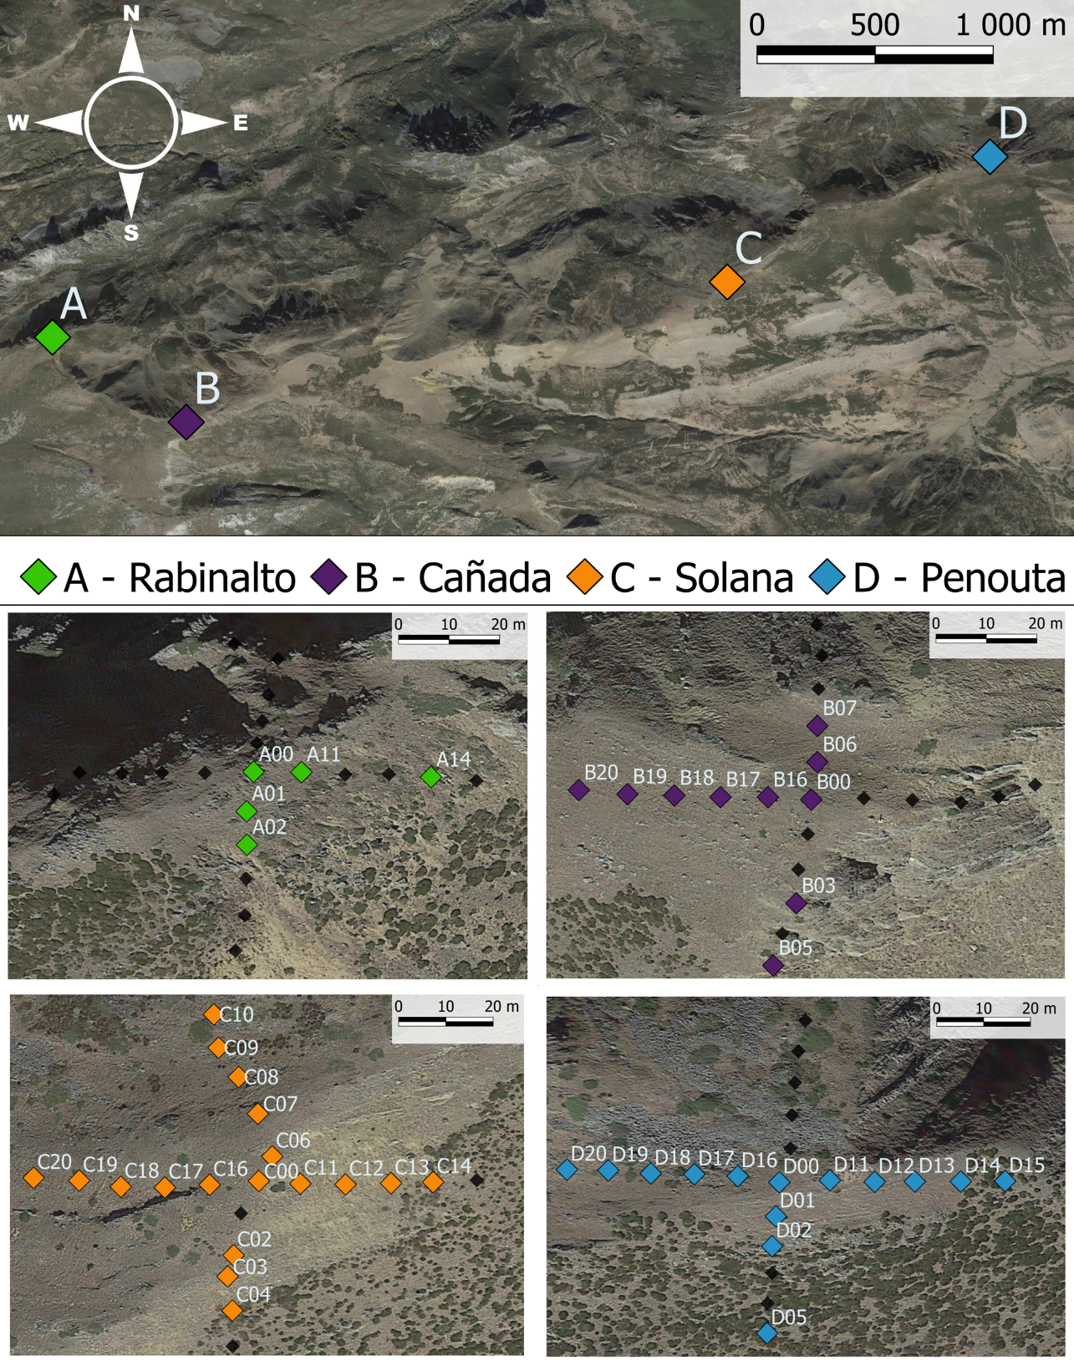

**Figure 2**. Field sites. Upper panel: Location of the four summits included in our study. Lower panels: Aerial image of our sampling cross design in each of the four summits, at each square we registered floristic relevés and buried environmental data loggers. Coloured squares represent subpopulations where *D. langeanus* was present; black squares sites where *D. langeanus* was absent.

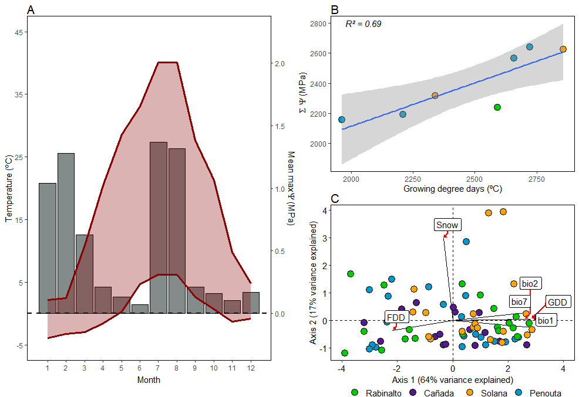

**ure**.Climate of the study sites. Climatic diagramaverages of the dailyaverages thedaily water stress P (-1.5 is considered the wilting point)Positive ccumulativewater stress theordination of the microclimatic indices for the.Efrom

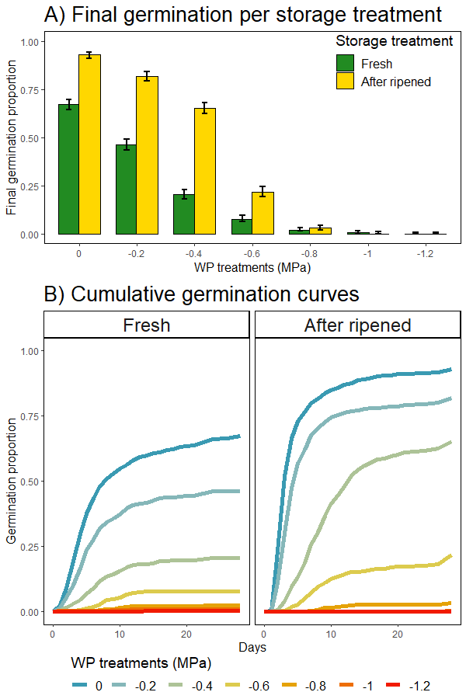

**ure**Germination responses to water stress in fresh and after-ripened seeds.

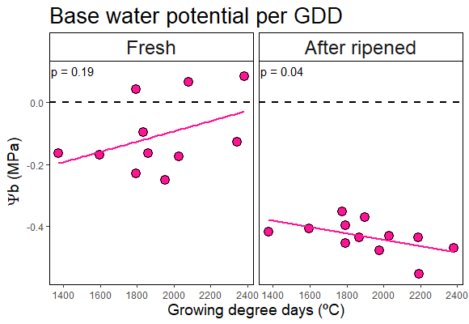

**ure**Germination base water potential as a function of subpopulation microclimate. Germination base water potential (Wb) was calculated using the hydro-time model. Microclimate was measured as growing degree days (GDD) above 5 ºC. obtained GLMMsthe m